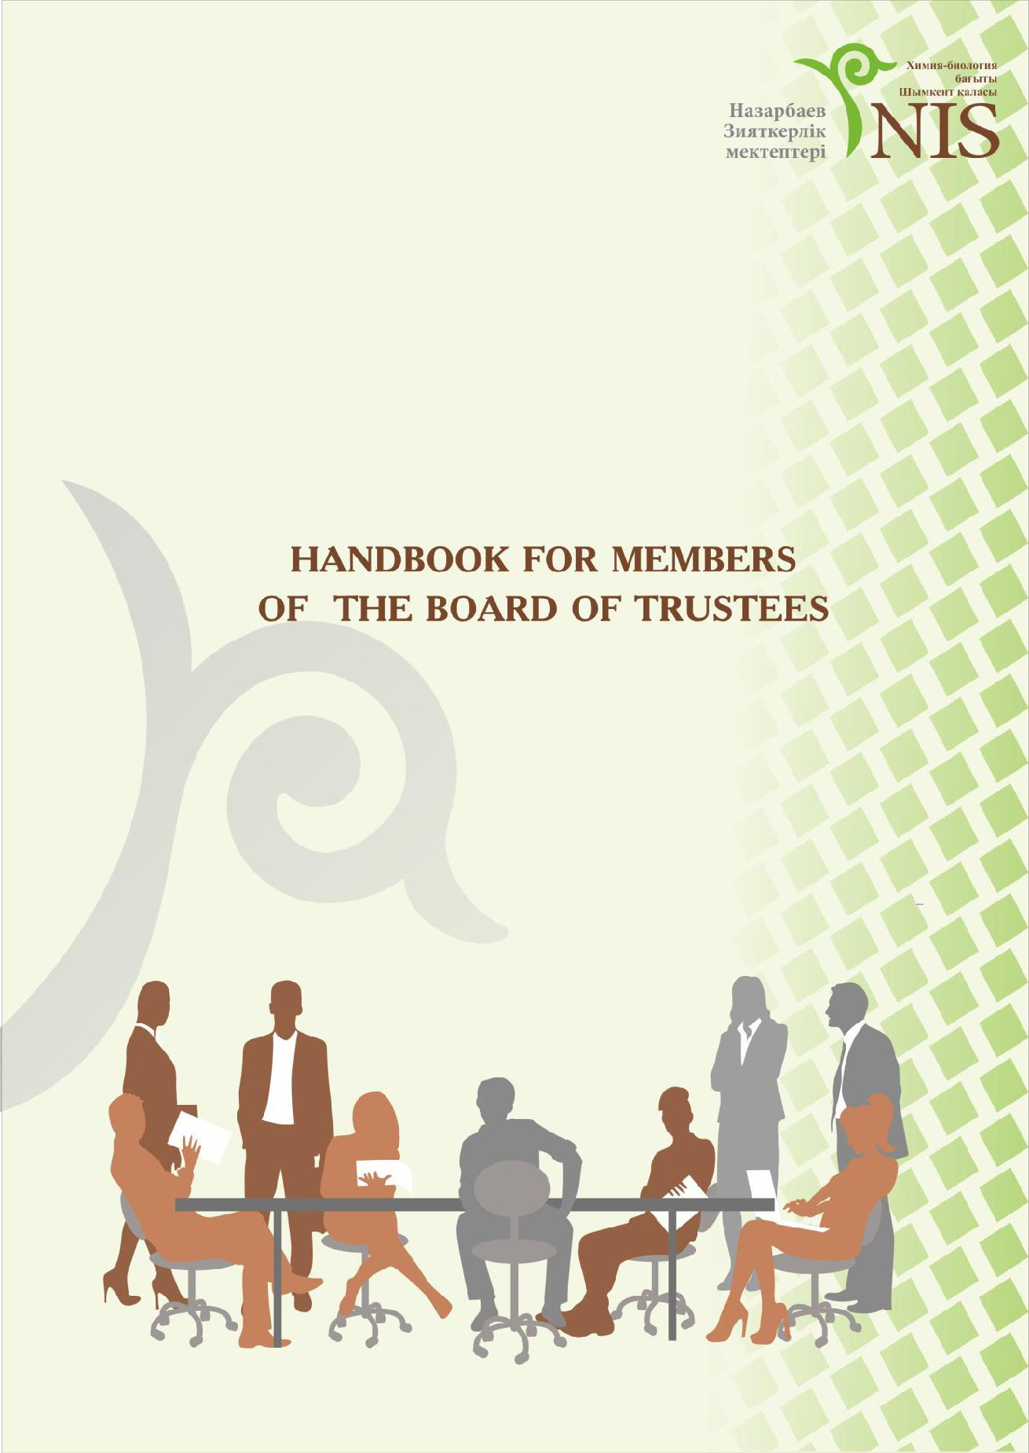
Nazarbayev Intellectual school of Chemistry and Biology in Shymkent

1

 | Nazarbayev Intellectual school of Chemistry and Biology in Shymkent
 |  | Contents
1 | Foreword……………………………………………………………………………. |  |  | 3
2 | Definition of internationalism and interculturalism…………………… |  |  | 5
3 | General provisions……………………………………………………………….. |  |  | 5
4 | Members of the Board of Trustees……………………………………….. |  |  | 6
5 | The competence of the Board of Trustees……………………………… |  |  | 7
6 | The rights and obligations of members of the Board of Trustees |  |  | 8
- Responsibility of members of the Board of Trustees……………….. 10

- Operation of the Nazarbayev Intellectual School Board of Trustees……………………………………………………………………………… 11

- Committees………………………………………………………………………… 15

- Conflict of interest………………………………………………………………. 16

- Forms, order of raising and allocating extra resources……………. 17
- Cooperation of the Intellectual School Board of Trustees with

the other regulatory bodies………………………………………………….. 18

- Final provisions………………………………………………………………….. 18

Appendix
  - Structure of the Board of Trustees of Intellectual school…………. 20

  - Template of the Agenda meeting of members of the Board of Trustees of Intellectual school………………………………………………. 21

  - Template of the Report meeting of the members of the Board

of Trustees of Intellectual school…………………………………………… 22

2

Nazarbayev Intellectual school of Chemistry and Biology in Shymkent

Foreword

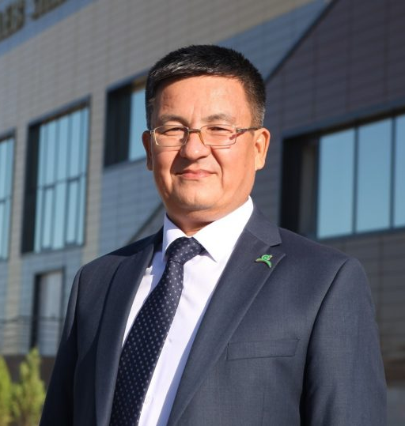
The modern world makes high demands on the education system. School education is aimed at creating competitive, highly educated, globally marketable, self-actualized, aware, creative, and critically thinking individuals. In the development of Kazakhstan's new generation, the Nazarbayev Intellectual school of Chemistry and Biology in Shymkent’s mission is to increase the intellectual capacity of Kazakhstan through

the development and implementation of an innovative, mathematics and science orientated, trilingual, model school system that integrates the best of Kazakhstan’s traditions and international standards of best practice.

In the education of the rising generation, considerable efforts are made by the Board of Trustees of the Intellectual School, in acting to implement the statutory goals of the school, hereby creating the necessary conditions for both students and the pedagogic staff of the school. Throughout their existence, the Board of Trustees have repeatedly assisted in the improvement of the material-technical base of the school in terms of the organization of students' educational, athletic, cultural and leisure activities.

On behalf of the entire staff of the school, I express our sincere and profound gratitude to the members of the Board of Trustees in providing grant aid in the implementation of the high performance activities of the Intellectual school.

3

Nazarbayev Intellectual school of Chemistry and Biology in Shymkent

SCHOOL GUIDING STATEMENTS

MOTTO
Changing the world starts with oneself.

MISSION

"We learn and build a better world, opening our hearts and minds."

VISION

As a school team, we aspire to be recognized leaders in education, aiding students in becoming global citizens and achieving success in a rapidly evolving information space.

EDUCATIONAL VALUES:

Respect
Transparency
Patriotism and Responsibility
Diligence and Creativity
Honesty
Family Values and Traditions
Health and Well-being
Global Citizenship

STRATEGIC DIRECTIONS OF SCHOOL DEVELOPMENT:

A. Guiding Statements

B. Teaching & Learning

C. Governance & Leadership

D. Faculty & Support Staff

E. Access to Teaching & Learning

F. School Culture & Partnerships for Learning G. Operational Systems

4

Nazarbayev Intellectual school of Chemistry and Biology in Shymkent

DEFINITION OF

INTERNATIONALISM AND

INTERCULTURALISM

We aim to create an awareness in the students of the political, scientific and cultural interdependence that exists in our world and the ways in which other people and cultures have an impact on our daily lives.

We plan to equip our students with the necessary skills for competing in a global economy.

We will achieve this through:

- Teaching multiple languages

- Teaching subjects through more than one language

- Teachers from different cultures

- ‘International’ events

- Learning about other countries

- Critical thinking lessons using multiple perspectives

- Teaching tolerance of other cultures

- Students take Examinations that are acceptable for University entrance in a number of countries

- Promoting recycling

- Developing student identity and their cultural awareness

- Student recognition and development of universal human values

- Contacts with students from other countries

- TedX

- Model United Nations

1. General provisions

The Intellectual School Board of Trustees is one of the forms of the Intellectual School’s collective management, which currently operates on a voluntary basis.

The aim of the Intellectual School Board of Trustees is to render assistance to the Intellectual School in fulfilling its tasks, as provided by the Provisions and to raise additional financial and other

5

Nazarbayev Intellectual school of Chemistry and Biology in Shymkent

resources, to maintain the facilities and increase the quality of educational services.

The Intellectual School Board of Trustees acts according to the Constitution and Laws of the Republic of Kazakhstan, the President and Government of the Republic of Kazakhstan, and other regulatory acts, such as, the standard regulations of AEO, the Charter of AEO and the present Provisions. Board of Trustees may not interfere in the current managerial activities of the Intellectual School administration.

- Members of the International School Board of Trustees

The membership of the Intellectual School Board of Trustees is approved by the AEO order, upon the recommendation of the Intellectual Schools’ Principals. The amount of members of the Intellectual School Board of Trustees should not exceed fifteen people.

The Intellectual School Board of Trustees consists of a Chairperson, members of the Intellectual School Board of Trustees and a secretary.

Representatives of the AEO, Intellectual Schools, local executive bodies, social organizations, parents of Intellectual Schools’ students, sponsors, and other people who are interested in the Intellectual Schools development can become members of the Intellectual School Board of Trustees.

Individuals who take an active part in the social life of the region and who have higher education can become members of the Intellectual School Board of Trustees.

The length of the period of service, of members of the

Intellectual School Board of Trustees is three years. Individuals/organizations can be re-appointed as members of the Intellectual School Board of Trustees only once, after the end of their initial service. If necessary, the Board can issue an order to make amendments to the conditions of membership.

The members of the Intellectual School Board of Trustees perform their duties on a voluntary basis.

The Chairperson of the Intellectual School Board of Trustees is a member who has been nominated and supported by the majority of the voters present at the first meeting of the Intellectual School Board of

6

Nazarbayev Intellectual school of Chemistry and Biology in Shymkent

Trustees. The voting is an open one.

The Chairperson of the Intellectual School Board of Trustees should be an expert in the educational field. He/she should be aware of the work and the specifications of the Intellectual Schools, and should have never been convicted of a criminal offence.

The Chairperson of the Intellectual School Board of Trustees is in charge of the Intellectual School Board of Trustees’ activity, plans its work, conducts meetings and signs orders made by the Intellectual School Board of Trustees. He/she also controls the implementation of decisions taken by the Intellectual School Board of Trustees, suggests measures to increase the quality and efficiency of the decision-making process, prepares the annual report for AEO about the work of Intellectual School Board of Trustees, cooperates with school administration, represents the Intellectual School Board of Trustees when cooperating with the State government bodies and other organizations, and takes responsibility for the activity and performance of the work of the Intellectual School Board of Trustees.

- Competence of the Intellectual School Board of Trustees

The сompetence of the Intellectual School Board of Trustees includes the following points:

- assisting the Intellectual School in reaching its charter goals, and creating the necessary conditions for students and pedagogical staff for the successful realization of its educational programs.

- making recommendations on the priority directions of the
Intellectual School’s development.

- assisting in protecting students’ health and organising different cultural events and recreation activities at the Intellectual Schools.

- working on the fulfillment of the contract signed between the
Intellectual School and the students’ official representatives.

- providing cooperation in rendering assistance to the students belonging to vulnerable social groups.

- providing cooperation in securing financial support through raising sponsorship and voluntary contributions, outlining directions,

7

Nazarbayev Intellectual school of Chemistry and Biology in Shymkent

forms, amount and operating procedures in relation to the use of sponsors, benefactor and other kinds of help, and lastly, control its distribution;

- discussing the reports of the School Principal regarding the work at the Intellectual School, based on the Intellectual School development plans.

- providing cooperation in search of partner resources in the Republic of Kazakhstan as well as abroad.

It should be noted that questions regarding the competence of the Intellectual School Board of Trustees cannot be transferred to other regulatory bodies of the Intellectual School.

- The rights and obligations of members of the Board of Trustees

The Chairperson of the Intellectual School Board of Trustees:

- Approves the work plan of the Intellectual School Board of
Trustees;

- Appoints the date, time and place for conducting meetings of the Intellectual School Board of Trustees;

- Allocates responsibilities to the members of the Intellectual School Board of Trustees;

- Sets the daily work agenda;

- Monitors the secretary who is in charge of the protocol during meetings of the Intellectual School Board of Trustees.

- Performs other functions.

The Chairperson of the Intellectual School Board of Trustees

does not have the right to refuse to conduct a meeting, except in cases when issues in the agenda are not in his/her competence.

In case the Chairperson of the Intellectual School Board of Trustees is away, his/her duties should be performed by one of the members of the Intellectual School Board of Trustees who is nominated by the Chairperson of the Intellectual School Board of Trustees.

All members of the Intellectual School Board of Trustees have

8

Nazarbayev Intellectual school of Chemistry and Biology in Shymkent

equal rights. A member of the Intellectual School Board of Trustees has the right:

1) To make suggestions concerning the activities of the Intellectual School Board of Trustees, and to discuss them in the meetings of the Intellectual School Board of Trustees;

- To express his/her opinion, which has to be noted in the protocol, in case a member disagrees with the Intellectual School Board of Trustees decision;

- To provide voluntary cooperation to the Intellectual School, including financial maintenance or personal contribution;

- To be aware of the activity of the Intellectual School within the limits of his/her competence, in case the information is necessary for performing the functions of the Intellectual School Board of Trustees members;

- To withdraw membership before the expiry date, at his/her discretion by submitting a written notice of resignation, mentioning if it is impossible to perform the duties, due to health reasons.

Members of the Intellectual School Board of Trustees who have limits to exercising their duties are allocated by the Chairperson of the Intellectual School Board of Trustees and their obligations are:

- To abide by and observe the regulations of the present Provisions;

- To take part in the activities of the Intellectual School Board of Trustees;

- To show loyalty to and respect the interests of the Intellectual School and AEO (i.e. he/she does not have the right to use the given opportunities to go against the aims of the AEO Charter and should refrain from using his/her position in behalf of other bodies);

- To raise and organize entry of the extra budget funds and property to secure the educational process and its development;

- To contribute to the formation of a financially stable extra-budgetary Intellectual School development fund;

- To keep the records of the activity of the Intellectual School

9

Nazarbayev Intellectual school of Chemistry and Biology in Shymkent

Board of Trustees;

- To act within the scope of the regulations as established by the present Provisions;

- To act in accordance with the values and ethical principles embodied in the AEO Code of Ethics, approved of by the order of the
AEO Board dated July 13, 2012 (protocol №29);

- Keep information about AEO, both during the period of service and after the termination of the relevant functions of the Intellectual School Board of Trustees member, strictly confidential;

10) To inform the Secretary (prior to) about the impossibility of taking part in the meeting and indicating the reason for absence;

11) To examine to the full extent the information (materials, documents) necessary for taking reasoned decisions;

12) To refrain from actions which lead or may potentially lead to conflict of interest, in case that happens, it should be reported to the Chairperson of the Intellectual School Board of Trustees;

13) To refrain from voting on issues when a member has a
personal inerest. To mention a personal interest and reasons behind it
to the Secretary;
14) To bring the following points to AEO’s attention:

Issues related to the primary work location (indicating the full name of the legal entity, identification number, legal address) and the position held;

Information about personal data (series, number of the document where and when it was issued), citizenship, identification number;

Details about the postal address, electronic mailing address, place of residence, contact number;

Information about the membership of trustees on other boards; Information about the participation in authorized funds of legal
entities.

- Responsibility of members of the Board of Trustees

Members of the Intellectual School Board of Trustees report to AEO for the performance of their functions, for the damage brought by their activity (inactivity) in accordance with the Law of the

10

Nazarbayev Intellectual school of Chemistry and Biology in Shymkent

Republic of Kazakhstan, which includes losses caused as a result of:

- Providing misleading or disorientating information;

- Violation of the order of reported information established by the Law of the Republic of Kazakhstan and the AEO regulatory acts;

AEO has the right to hold responsible, a member of the Intellectual School Board of Trustees for compensation for the damage and/or losses caused.

Members of the Intellectual School Board of Trustees do not have the right to get involved in the official activities of the Intellectual School’s employees.

The Intellectual School Board of Trustees can take a decision to exclude a member of the Intellectual School Board of Trustees for objective factors which include:

- Lack of participation of the member of the Board of Trustees in the work of the Intellectual School Board of Trustees;

− Participating in activity of the Intellectual School Board of Trustees which runs against the interests of the Intellectual School;

- a conflict of interest of a member of the Intellectual School Board of Trustees and Intellectual School.

In case a member of the Intellectual School Board of Trustees resigns voluntarily, the new member of the Intellectual School Board of Trustees is appointed on equal terms to that of the member leaving the Intellectual School Board of Trustees. Any full-time re-election is considered to be first full-time election of the member of the Intellectual School Board of Trustees.

- Operation of the Nazarbayev Intellectual School Board of Trustees

Meetings of Nazarbayev Intellectual School Board of Trustees are held accordingly, at least three times in an academic year. The meetings of the Nazarbayev Intellectual School Board of Trustees can be self-initiated by its Chairperson, initiated by AEO, 1/4 of Nazarbayev Intellectual School Board of Trustees or Principal of Intellectual School.

At the meetings members can have the legal power to take decisions, if there are at least 2/3 members of Intellectual School Board of Trustees. Decisions of the Intellectual School Board of Trustees

11

Nazarbayev Intellectual school of Chemistry and Biology in Shymkent

should be made by the majority of the voters. Decisions of the Intellectual School Board of Trustees should be brought to the attention of all parties.

Suggestions of the Intellectual School’s Board of Trustee should be made to the Chairperson of Intellectual School Board of Trustees in a written form which provides the following information:

- outline;

- denotation of initiator (full name of the initiator);

- reasons for including the questions into the agenda;

- information and materials, which are given the members of the Intellectual School Board of Trustees;

- the address where the answer to the offer should be sent;

- summary of decisions on agenda.

Offers about holding a meeting of the Intellectual School Board of Trustees should be signed by the initiator.

If an offer for holding a meeting of the Intellectual School Board of Trustees is accepted, the meeting should be held no later than fifteen, but no sooner than, five working days from the date of making the offer.

Meetings can be held in another place or time, in case the time and the place of the initiated meeting have changed.

All members of the Intellectual School Board of Trustees should be informed beforehand about the change of place or time of meeting of Intellectual School Board of Trustees, so that they have enough time to come to the meeting. Information about the changes should be sent to members of the Intellectual School Board of Trustees in any form, which guarantees them receiving the information.

Members of the Intellectual School Board of Trustees should participate in meetings personally. Each member of the Intellectual School Board of Trustees has one vote. Passing a vote from one member of the Intellectual School Board of Trustees to another is prohibited. The Chairperson of the Intellectual School Board of Trustees has the deciding vote, in case of a tie in the votes of members of Intellectual School Board of Trustees.

12

Nazarbayev Intellectual school of Chemistry and Biology in Shymkent

An Intellectual School is the performing structure of the Intellectual School Board of Trustees, the Board of Trustees works under it. The Secretary of the Intellectual School Board of Trustees should be appointed to the post from the staff of this Intellectual School, and he/she is not member of Intellectual School Board of Trustees.

The secretary of the Intellectual School Board of Trustees should provide all members of Intellectual School Board of Trustees with materials and the agenda about holding a meeting, no later than five working days before said meeting.
- The information should contain:
1) Place and time of meeting;
2) Explanation of a possibility of a member of the Intellectual

School Board of Trustees to vote through sending a written letter on agenda, in case when he/she cannot participate in a meeting because of a valid reason.

The agenda of the meeting with the notification of reporter; background materials, which contain inclusion of the questions in the agenda; necessary documents of meeting, which are given to members of Intellectual School Board of Trustees, all of these should be obligatorily appended to the information.

The term of sending information with necessary materials can be shortened to 3(three) working days by the decision of Chairperson of Intellectual School Board of Trustees, in case of an emergency.

The secretary prepares the necessary documents and materials meeting of Intellectual School Board of Trustees and makes the protocol; he/she is responsible for correct note-taking of the protocol, recording and keeping protocols of meetings of Intellectual School Board of Trustees in a safe place.

A member of Intellectual School Board of Trustees, who has been informed about the meeting , should inform the secretary of Intellectual School Board of Trustees about his/her participation in said meeting, no later than one day before the date of the holding of the meeting.

Decisions of Intellectual School Board of Trustees are taken by open vote and are accepted if most of the members of the Intellectual School Board of Trustees who participate in a meeting vote in favor of it, and are written in the protocol, which is signed by the Chairperson

13

Nazarbayev Intellectual school of Chemistry and Biology in Shymkent

and the secretary of the Intellectual School Board of Trustees.

In order to consolidate the positions of members of the Intellectual School Board of Trustees, all members of the Intellectual School Board of Trustees, who have participated in a meeting give the secretary of Intellectual School Board of Trustees signed voting forms, which are made according to the appendix instructions of the present Provision.

- Protocol of meeting of Intellectual School Board of Trustees is made no later than 3 (three) working days after it.
  - Details of the protocol:
- Date, place and time of meeting;
- Information about participants of meeting;
- Agenda;
- Views of reporters;
- Questions, which were raised in the vote and results of vote;
- Decisions made;

- Additional information about the decisions of the Intellectual School Board of Trustees.

At the meeting of the Intellectual School Board of Trustees, decisions are taken only about questions, which are included in agenda.

An initiator of a question on the agenda can exclude his/her question from the agenda at any time before rendering a decision; it is registered strictly in the protocol.

In the course of any meeting additional questions (no more than three additional questions) of the Board of Trustees of Intellectual school can be included in the agenda and then considered. If the majority of the members of the Board of Trustees of the Intellectual schools participating in the meeting vote for their inclusion in the agenda.

The procedure of holding a meeting of the Board of Trustees of
Intellectual School:

- consideration of a question about taking decisions of the Board of Trustees of Intellectual School;
- discussion of the agenda;
- voting the agenda;
- calculation and tally of votes;

- announcement of the voting results and decisions (if it is necessary, deadlines are noticed), which are taken about questions on the agenda.

14

Nazarbayev Intellectual school of Chemistry and Biology in Shymkent

A meeting of the Board of Trustees of Intellectual school is held with obligatory participation of the person, who made an offer to hold the meeting. Persons who are not members of the Board of Trustees of Intellectual school can be invited to the meeting of the Board of Trustees of Intellectual school.

Materials and protocols of the meetings of the Board of Trustees of Intellectual School are kept by performing body of the Board of Trustees of Intellectual School and when it is necessary can be given to members of the Board of Trustees of Intellectual School for review with requirements’ compliance of providing safe-keeping of commercial, official and other types, at the same time confidentiality regarding AEO information should be kept.

Protocols of the meeting of the Board of Trustees of Intellectual School are documents which are always kept in a File Register and given in an appropriate manner of reception and transferring of file records in archives.

7. Committees

The board of Trustees of the Intellectual School act according to the decision of the majority of the members. They can make one or more committees of branch areas. The participants of committees are determined by the decision of the Board of Trustees of the Intellectual School. Committees should consist of three or more members of the Board of Trustees of the Intellectual School. Setting up committees does not excuse any member from the held responsibility.

Members of the Board of Trustees of Intellectual School can be included in no more than two committees.

The Chairperson of the Board of Trustees of Intellectual School is elected at a meeting from the members of the Board of Trustees of Intellectual School by open voting with majority of votes of the Board of Trustees of Intellectual School, who participate in meeting. The Chairperson and members of the Board of Trustees of Intellectual School make suggestions for the chairperson of the committee.

Depending on suggestions of the committee members the Chairperson can be changed, if the majority of the Board of Trustees of Intellectual School voted for that.

15

Nazarbayev Intellectual school of Chemistry and Biology in Shymkent

The Chairperson of committee can be withdrawn from committee if he/she wishes.

The Chairperson of Committee:
- Leads the work of Committee;

- Makes plan for the work of Committee and makes project of meeting agenda;

- Gives orders to the members of committee, which are related
to the work of the committee.
4)

The Chairperson holds the presidency during the meeting. Meetings are held depending on the need.

The Chairperson informs members of the committee about the meeting of the committee no later than two working days and informs other participants beforehand.

The committee can request documents and materials, which are necessary for their work, and can invite specialists, parents, teachers and other people and consider their questions, which can be taken into consideration by the Committee.

Decision of a committee is taken by majority of votes and prepared by protocol, which is signed by the Chairperson of that committee. Each member of Committee has one vote. Passing a vote from one member of Committee to another is prohibited. In case of equality of votes the Chairperson of Committee has to make the decision.

Decisions of a committee are passed on approval of the Board of Trustees of Intellectual School.

The order of the operation of committees’ work is determined by the decision of the Board of Trustees of the Intellectual School.

If it is necessary new committees established, and previous committees can be abrogated and re-organized.

8. Conflict of interest

Conflict of interest is a situation when there is a contradiction between the personal interest of the Intellectual School Board of Trustees member and the proper performance of his/her obligations or legal interest of physical and legal bodies or state which may harm the legal interest.

16

Nazarbayev Intellectual school of Chemistry and Biology in Shymkent

Each member of the Intellectual School Board of Trustees is obliged to serve according to the interest of the Intellectual School and perform his/her duties only to the interest of the School. Members of the Intellectual School Board of Trustees do not have the right to priorities personal interest when taking decisions and to use commercial opportunities of the Intellectual School for personal advantage.

In case of arising conflict of interest, or a possible arising, a member of the Intellectual School Board of Trustees must inform the Chairperson Intellectual School Board of Trustees in a written form, ASAP. The Chairperson of the Intellectual School Board of Trustees must exclude the member from considering the issue, which caused the arising of the conflict of interest.

The Intellectual School Board of Trustees is obliged to inform AEO about the arise of conflicts of interest between the Intellectual School Board of Trustees (a member of the Intellectual School Board of Trustees) and other employees of Intellectual Schools and measures should be taken to resolve the issue.

Provided that it is impossible to solve the issue independently, the AEO should consider the matter.

- Forms, order of raising and allocating extra resources.

The Intellectual School Board of Trustees raises extra resources in the form of contributions of physical and legal bodies, sponsorship, voluntary donations and other sources as stated in the Laws of the Intellectual School.

The target contributions over investor claim should be entered into banking institutions in the special account of the Intellectual School.

The allocation of target contributions raised by the Intellectual School Board of Trustees is used by the Principal of the Intellectual School according to the stated designated purpose in accordance with the Intellectual School Board of Trustees.

Physical or legal bodies may make sponsorship support in the form of material or financial resources in accordance with the procedure established by the legislation.

Every year the Principal of the Intellectual School submits to the

17

Nazarbayev Intellectual school of Chemistry and Biology in Shymkent

Intellectual School Board of Trustees a report regarding the |  |  | allocation
of the target contributions and means received from a sponsor.
The property received from the target contributions, |  |  | sponsor
support and other sources should be used promptly. It should |  |  | be signed

as property of the Intellectual School and that has to be noted on the balance register on a separate account according to the established procedure.

Transparency should be observed in accordance with the regulations by the Civil Code of the Republic of Kazakhstan.

- Cooperation of the Intellectual School Board of Trustees with the other
regulatory bodies
The Intellectual School Board of Trustees cooperates with the other

regulatory bodies through the participation of its members in teachers’ council, parents’ council, methodical council and other regulatory bodies’

meetings.

11. Final provisions

Each new member of the Intellectual School Board of Trustees has the right to review documents concerning the activity of the Intellectual School Board of Trustees.

The AEO Board makes all changes and/or supplements to the present Provisions.

Termination of the Intellectual School Board of Trustees’ activity comes into effect:

  - Based on the AEO Board;

- According to the regulations of the Intellectual School Board of Trustees;

  - Upon the liquidation or reorganization of the Intellectual School.

After taking the decision about the liquidation, means of the

Intellectual School Board of Trustees should be sent to the AEO , the
legal and physical bodies, if reorganization is needed they should be

18

Nazarbayev Intellectual school of Chemistry and Biology in Shymkent

transferred to the legal successor for completing projects approved by the Intellectual School Board of Trustees.
Matters regarding the work of the Intellectual School Board of

Trustees not considered in the present Provisions should be considered
in accordance with the Law of the Republic of Kazakhstan, AEO
Charter and other AEO regulatory acts.

19

Nazarbayev Intellectual school of Chemistry and Biology in Shymkent

Appendix 1

Structure of the Board of Trustees of Nazarbayev Intellectual School of Chemictry-Biology Direction

1 | 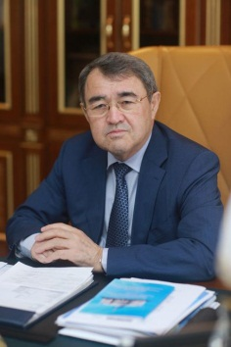 | Serikzhan Seitzhanuly Seitzhanov  The head of the Oil and Gas Company Yug-Oil" LLC
2 | 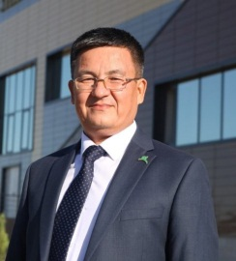 | Balkan Maratovich Kasimov  Principal of Nazarbayev Intellectual School Chemistry and Biology Direction in Shymkent City
3 | 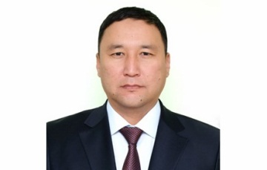 | Mukhtar Kalsabayevich Torybayev  Head of the customs post “Atameken” of the State Revenue Department for the Turkestan region.
4 | 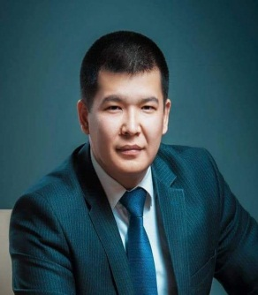 | 4. Maxat Zhanabululy Alibayev  Director of the Shymkent City Branch of RSE "National Institute of Intellectual Property".
5 | 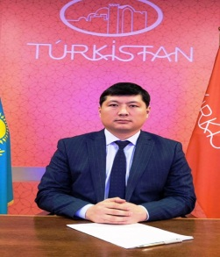 | 5. Yerlan Bakhytzhanuly Kuzembayev  Head of the Administration for the city mayor (akim) of the city of Turkestan  23
6 | 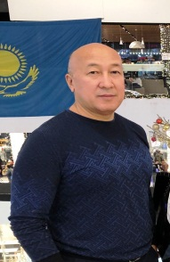 | Amanbai Abdugarimovich Ezhanov  The head of "Belasarfarm" LLC
7 | 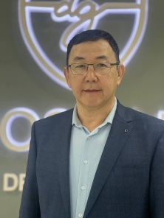 | Akhatai Ramazanovich Tleukeev  Head of Doscar Chevrolet Shymkent
8 | 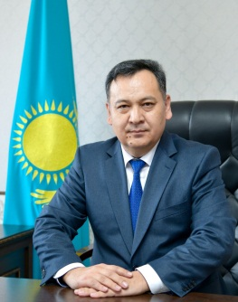 | Rakhimberdy Zhanysbekuly Mulkemanov  Mayor (akim) of Karatau District of Shymkent City  24

Appendix 2

20

Nazarbayev Intellectual school of Chemistry and Biology in Shymkent

Template of the Agenda meeting of members of the Board of Trustees of Intellectual school

Date : «____»_____ _____

Place: __________

Members of Council listed below took part in the meeting of meeting of

Board of Trustees:

- Full name– position

- Full name– position

Meeting’s agenda:

1.

2.

Chairman : ______________Full name

Secretary: ______________ Full name

Members of Board of Trustees:

__________________________________ Full name __________________________________ Full name __________________________________ Full name

Appendix 3

21

Nazarbayev Intellectual school of Chemistry and Biology in Shymkent

Template of the Report meeting of the members of the Board of Trustees of Intellectual school

№_____

Place_____ «____»____________ _____

Address______________

Meeting’s agenda:

1.

2.

Decision:

Members of Board of | “Support”/ | “Against” | “Undecided” | Notes
Trustees | “Accept”

Last day of submitting/provision of bulletin:

«_____»_________2015

Address of submitting/provision of bulletin: ______________________

Name of member of Board of Trustees _______________________ __________

(signature)

«_____»____________ ______

22

Nazarbayev Intellectual school of Chemistry and Biology in Shymkent

23

